# Lightning Web Components

## CSS Box Model



# JavaScript Topics To learn



## Const vs let vs var



Let keyword -> cannot redeclare the let variable.

Const - > cannot updated or redeclare.



## BigInt Data Type

bigInt data type -> var x = 101232131312511n; here n denotes bigint number.

## NULL vs UNDEFINED



## Spread Operator ( … operator, triple dot operator)







## Problem with Array copy



## How to fix this issue of reference copy with push method, & make it shallow copy?



# Destructuring

Unpack array elements or objects properties into variables





# String Interpolation (back tick, dollar use )



String methods – includes(), slice()

Object methods – object.keys(), values(), JSON.stringify(), JSON.parse()

# Array methods

## Map()



## Filter()



## Every()



## Some()



## Sort()



## Reduce()



# Import vs export module





# Event Propagation/flow

How the events are received on the web page from the element of page where event occurs & propagated throughout the DOM tree.

## Two models –

## Event Bubbling – Bottom to Top event flow, happens bydefault.







## Event Capturing – Top to bottom event flow

# Custom Event





# Salesforce DX (developer experience)

* Vs code (install from web)
* Salesforce cli (install from web)
* Salesforce extension pack



# Dev Hub vs Scratch Org vs Sandbox

Dev hub – main developer org, used to create & manage scratch org

Scratch org – source driven, disposable deployment of sf code & metadata. Temporary instance of salesforce dev. Limited to 1 to 30 days, then it expires.

Sandbox org – copies of prod.

# Perquisite to create scratch org with sample data



To make LWC components visible and publish to ORG, make sure you isExposed and Target components are specified.

# Naming Conventions Terminologies

* Camel case – let **carBrandName** = ‘Maruti’, usage is in LWC component names
* Pascal Case – public void **GetCarBrandName**(), usage is in Components class name.
* Kabab Case – **hello-world,** usage is when referencing components in another components or html data attributes.

## One way Data Binding





## Two way Data Binding







NOTE : In above case, track aren’t used because they are no longer used. All fields in LWC are reactive in nature. Before Spring 20’s, we must decorate these fields as @track to make them as reactive fields. Now, it is no longer required.

# Only one use case where @track is required, Complex data ?



## How to get rid of using @track ?



# Why Getters introduced in LWC ?

When getters are used, they rendered the component whenever the property in the getters are changed.

## Issue without using Getter





## How getters resolved this issue ?

 

# Implement Toggle using If:true/false Directive







# New Spring 23 season Improved Conditional Directives (lwc:if, lwc:elseif, lwc:else)

## Issues with traditional if:true/false ?



Getter isTemplateOne will be called and rendered multiple times based on directives calls, which ad the performance cost.



# For:each, for:item directive (looping)

 

# Why iterator loop is used over for:each loop directive ?

When someone wants to apply some action/any behavior they want to achieve over first/last item of the list, then use this iterator loop to apply behavior directly instead of tracking using index property which is used in for:each as well.

 



Quiz App Code - <https://github.com/GRawatCoder/LwcLearning>

# Components Composition

## Kabab Case –

Here, we will replace capital letter with small letter & prefixed with hyphen.

Examples-

childComponent <c-child-component></c-child-component>

childComponentDemo <c-child-component-demo>

childComponentDemoLWC <c-component-demo-l-w-c>

Here, one important note is for this hierarchy if we include child components in parent component, then for meta xml file, we should expose only parent component, no need to expose meta for child.

# Shadow DOM

DOM stands for document object model, tree structure representation of web page or its elements structure.

When you want to embed one component inside another component, then you are actually embedding shadow dom inside DOM. Hence, shadow dom is a dom inside a dom.









# Access Elements in LWC





# CSS Styling in LWC

## Pseudo class



## Inline Styling





# Design Tokens

Entities that store attributes and their values already built-in. We just need to use these tokens instead of hard coded values such as HEX values, RGB values etc.





# Shared CSS Component in LWC

In this we create a separate new LWC component containing only .CSS and meta file, deleting the rest. Write all duplicate CSS styling in here, & then import this CSS file in other component’s CSS files.

## Shared CSS component





**One LWC component**





**Second LWC component**





## Dynamic CSS in LWC

Dynamic css approach is the strategy we used when we need to apply CSS at run time or dynamically against the html component.



## Shadow Dom Styling, Applying some other styling to standard salesforce components?

Issue: suppose you have used Lightning-button and apply a custom class to modify color and font-color, you will not be able to apply these modifications to this standard sf button. So, to do so, you must apply CSS styling by writing code in JS to shadow dom.







Solution



# LWC Lifecycle Hooks

Lifecycle hooks are callback methods that are triggered at a particular phase of component instance lifecycle.

## What is Callback function in Javascript ?

Callback function are function that are passed to another function as an argument which is invoked inside outer function to do some logic.



The benefit of using a callback function is that you can wait for the result of a previous function call and then execute another function call.

## 3 phases of lifecycle in LWC

1. Mounting phase – Create components, insert the component in DOM, and render the components.
2. Unmounting phase – When components are removed from DOM, then this phase occurs.
3. Error phase – Whenever there is any error in lifecycle hooks callback, the error comes in Error phase.

## Mounting Phase

1. Constructor method – This is invoked when component instance is created. You have to call super() inside constructor. Public properties aren’t available in constructor.
2. ConnectedCallback() – called when element is inserted in DOM. Can’t access child components. We use this method to initialization task whenever we want to call service early on load of the page such as fetch data, setup cache, listen for events (pub/sub).
3. RenderedCallback() – Fires when component rendering is done. Whenever there is change in the component it fires again & again. When component re-renders, all expressions used in the html template are evaluated again.



Parent Component -> constructor called -> Check public property is to be update or not? If yes, then update the public property-> Connected Callback called-> component rendered -> Check if there is any child component-> if yes, trigger whole life cycle of child component again until there is no child component-> call RenderedCall back of all child components first,-> then call RenderedCallback of parent component.





## Unmounting Phase

1. disconnectedCallback() – fires when component is removed from DOM. This method is used to avoid memory leak issues.





## Error Phase

1. errorCallback(err,stack) – err is an object, stack is a string, this gets fired when there is any error in any other lifecycle hooks or child components.







## Render method

* Protected method on Lightning Element Class.
* Tells the component which template/HTML to load based on some conditions.
* Returns template reference.





# Communication between Components (Parent to Child)

4 approaches through which we can send data from Parent to Child?

1. Passing Primitive data to child
2. Passing non-primitive data to child
3. Passing data on button action to child
4. Calling child method on parent

## @api Decorator?

To make field/property/method as public, we need to decorate the same with @api decorator.

## Passing Primitive Data to Child Component

In child component, we must declare @api public property in child so that parent component send data to these child public properties.





In parent component, we must declare these public properties as attributes & pass data directly.



## Passing Complex Data to Child from Parent Component

Passing of complex data is also like passing primitive data.

Parent Component





Child Component





## Passing data to child based on action.

Again, same as earlier.

Parent Component





Child Component





## Calling Child method from Parent

In this, we will expose child method with @api decorator and in parent component, we will call this method from JS file via this.template.querySelector(“childcomponentname”).method().

Child component





Parent component





# Communication from Child to Parent Component

1. Calling parent using simple Event
2. Calling parent using event with data
3. Event bubbling

## Calling Parent using Simple Event







In this, we will dispatch event from Child component, the parent component will receive the event and do further operation.

Child Component





Parent Component





## Child to Parent Event Communication with Data





## Child to Parent event communication via event bubbling

In this, we will add bubbles property in event data to true, by default it is false. Once it is true, it will trigger JavaScript event bubbling in which all events if found from bottom to top hierarchy of DOM will trigger.

Child Component





Parent Component







# Communication from one independent component to another independent component

1. Pubsub – JavaScript standardised way to communicate.
2. Lightning Messaging service – Salesforce standardised way to communicate.

## Publisher Subscriber Pattern







## Pubsub JS library



Component A



Component B



# Getter & Setter use in LWC

Setter and getter when used in combination, they are used to perform complex logic before returning the value. Here, in parent & child hierarchy example, we have used setter to perform logic on value received from parent, then showing the final value to child.

Parent Component





Child component





## Slots

It is a placeholder for html to pass html to another component. It is used to catch html passed by parent component.

Named Slot – with name attribute  
Unnamed Slot – without name attribute.

**Parent Component**



3 slots are created –

1. Slot = icon
2. Slot = title
3. Slot = message

Child Component





# CSS behaviour in LWC

1. CSS in parent component cannot be applied to child component. If parent and child components has <h1> tag and if we add css to this h1 element in parent component, then this styling will not get reflected to child component.
2. Parent component CSS can style a host element i.e. child component (c-child-component-name).
3. We can style the host element from child component CSS as well using :host.



1. We can style slot element from parent component only.

# Communication between Aura & LWC

1. Pass data to LWC from Aura 2. Pass Event based data from LWC.

Aura Component





LWC Component





# Lightning Messaging Service

This service used to communicate between visual force, lwc, aura components.

## Setup LMS

1. Create messageChannels folder inside force-app/main/default
2. Create meta xml file under this folder.



LWC to LWC Communication using LMS.

Component A





Component B







# Fetch images from static resources.









## Fetch 3rd party JS & CSS library in LWC







loadScript – uses to load js files

loadStyle – uses to load Css files.

## Download Content files (PDF) from Salesforce in LWC









## Internalisation support in LWC

Import internationalization properties from the @salesforce/i18n scoped module. Lightning web components have internationalization properties that you can use to adapt your components for users worldwide, across languages, currencies, and timezones.





## How to access Custom labels in lwc

They are text values that are stored in salesforce and that can be translated into any language that salesforce supports. Custom labels are changed on the fly without even have to deploy the changes to org. module - @salesforce/label/c.labelname

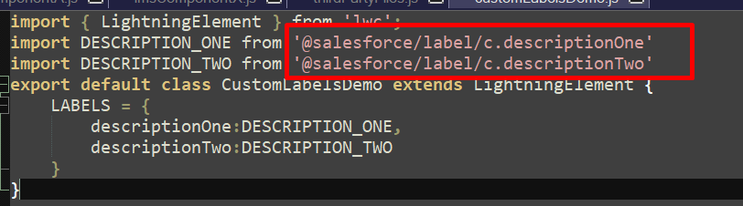

## How to access permissions in lwc

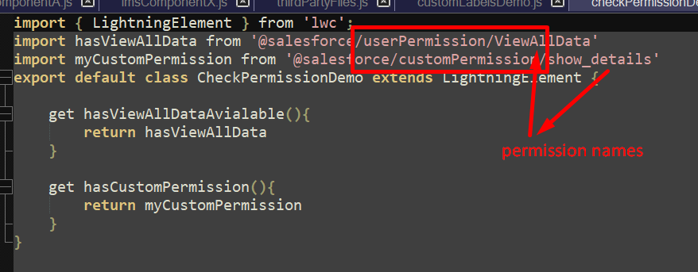

## Get Form factor in lwc

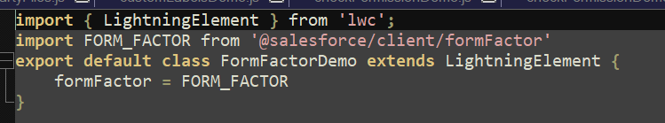

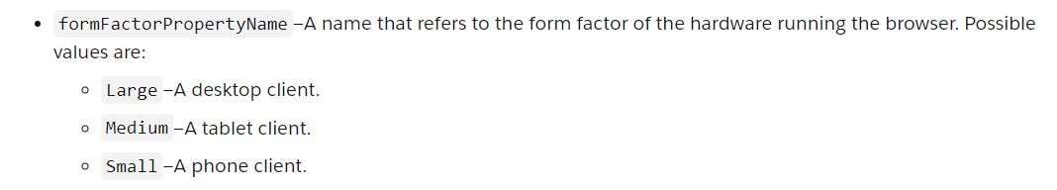

## Fetch user info

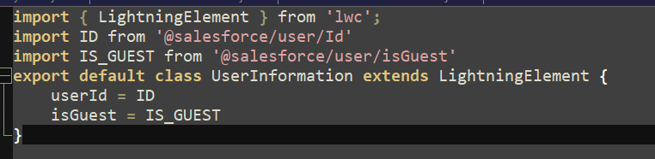

## Fetch record and object name from detail page

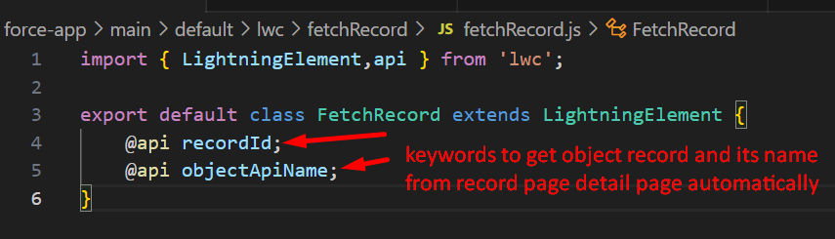

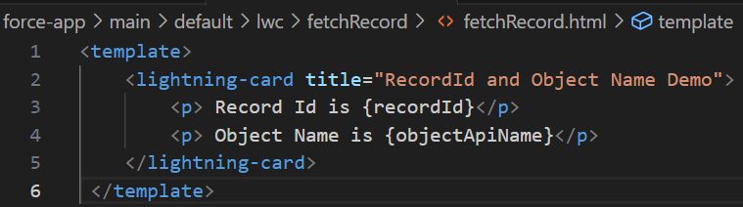

# Toast Notification

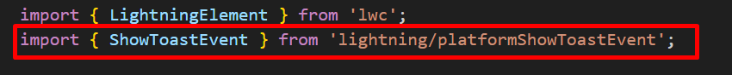

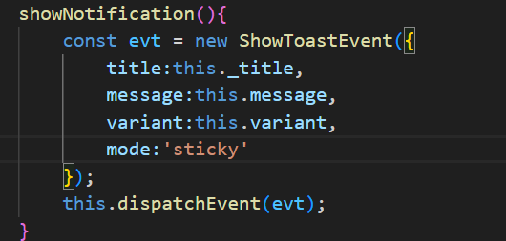

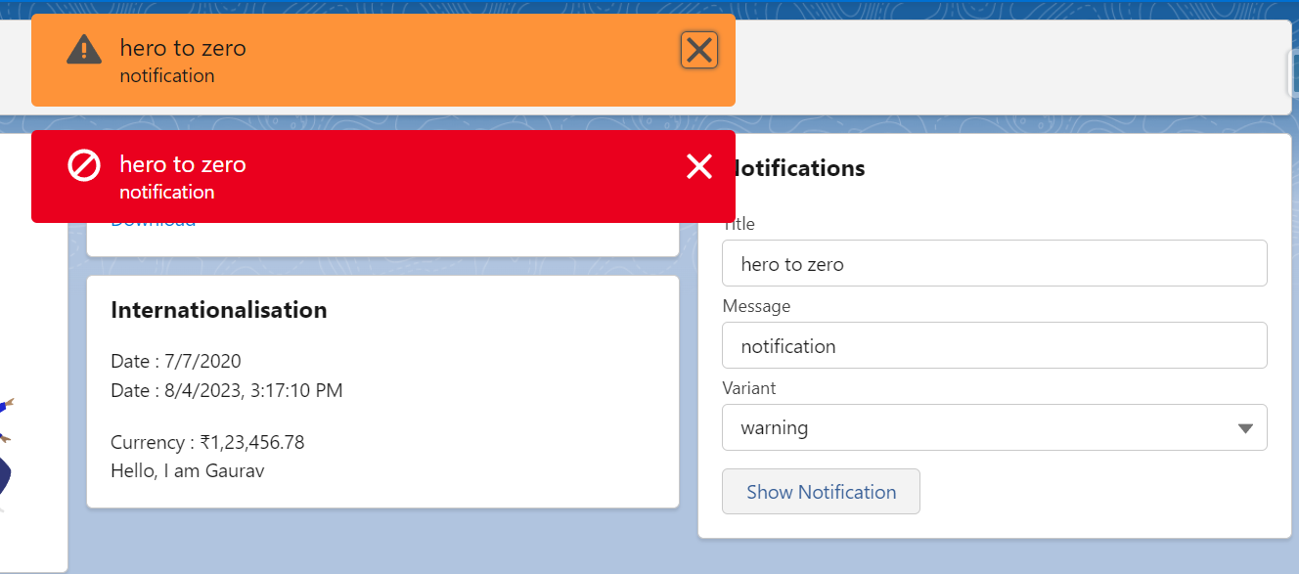

# Navigation Services

## Navigate to Home page

Use of lightning/navigation module

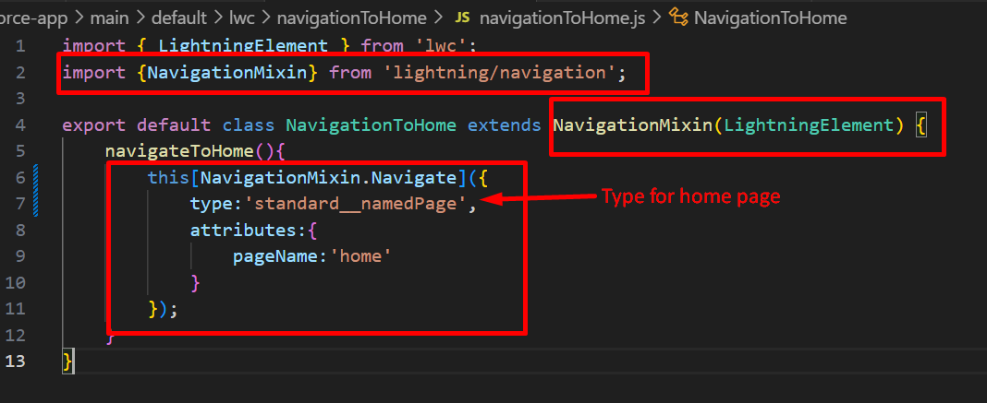

## Navigate to chatter

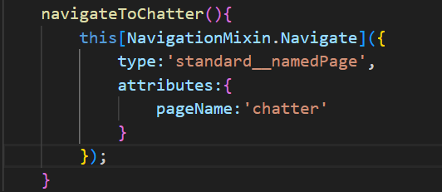

## Navigate To Object Pages with Values

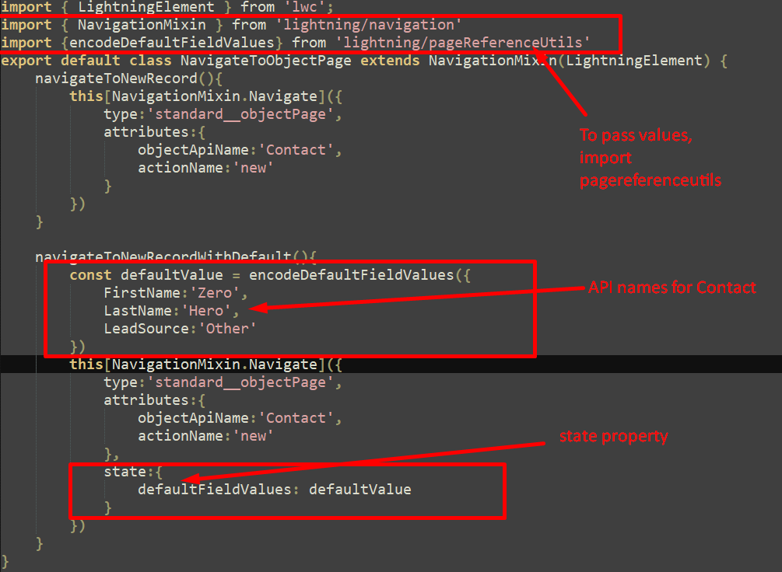

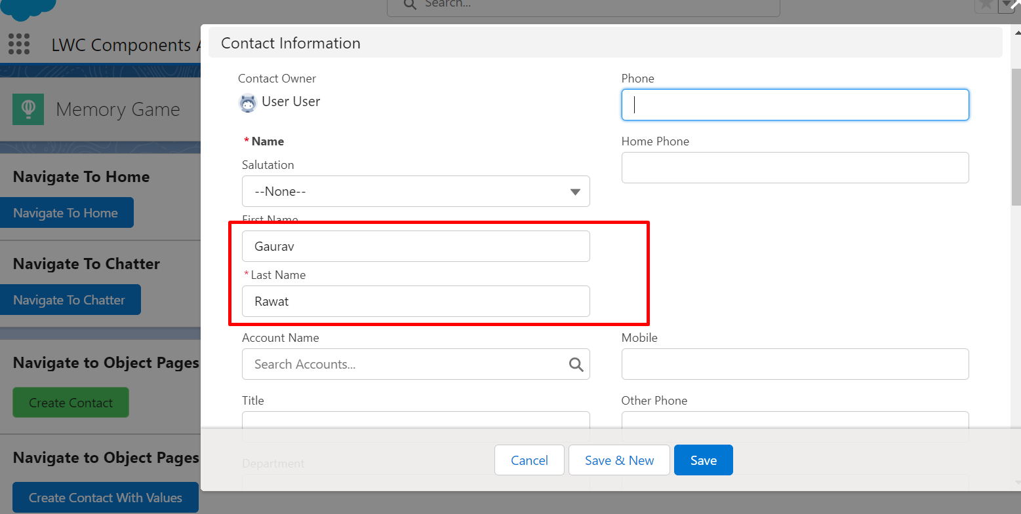

## Navigate to Object Page List view

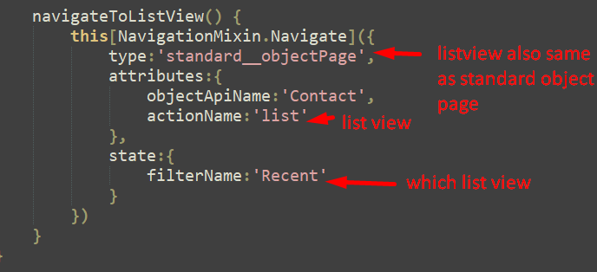

## Navigate to files

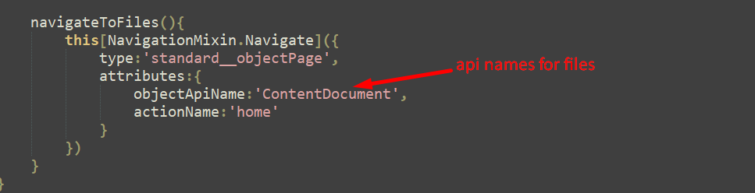

## Navigate to Record Page

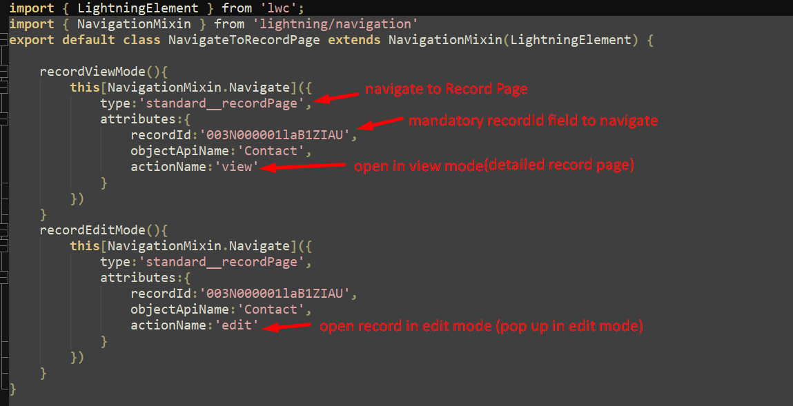

## Navigate to Tab

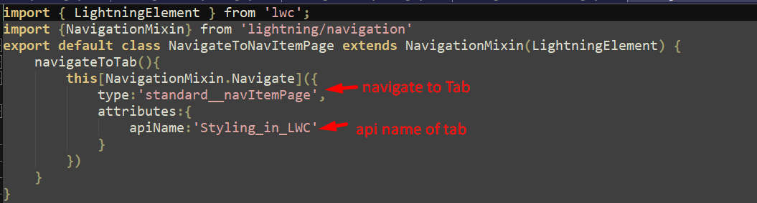

## Navigate to Relation Tabs of Object

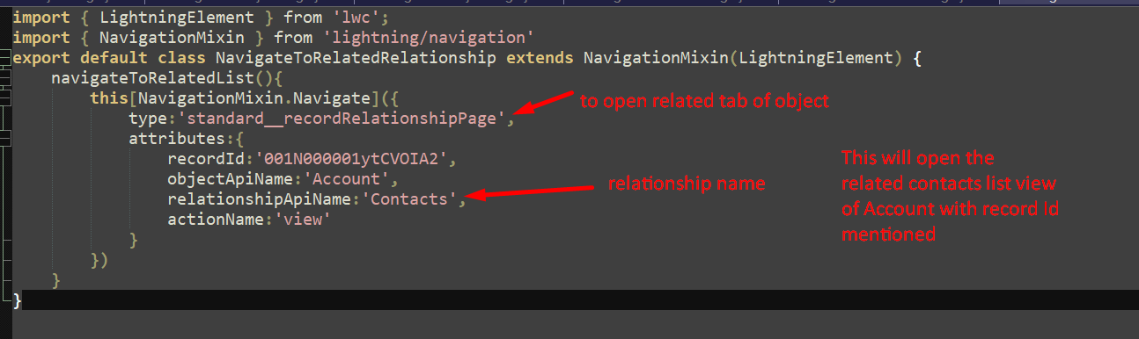

## Navigate to Web page

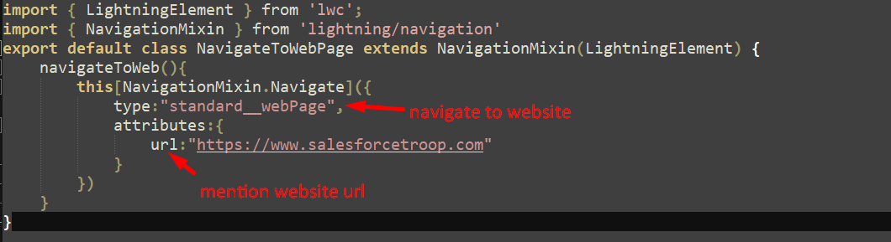

## Navigate to another LWC page

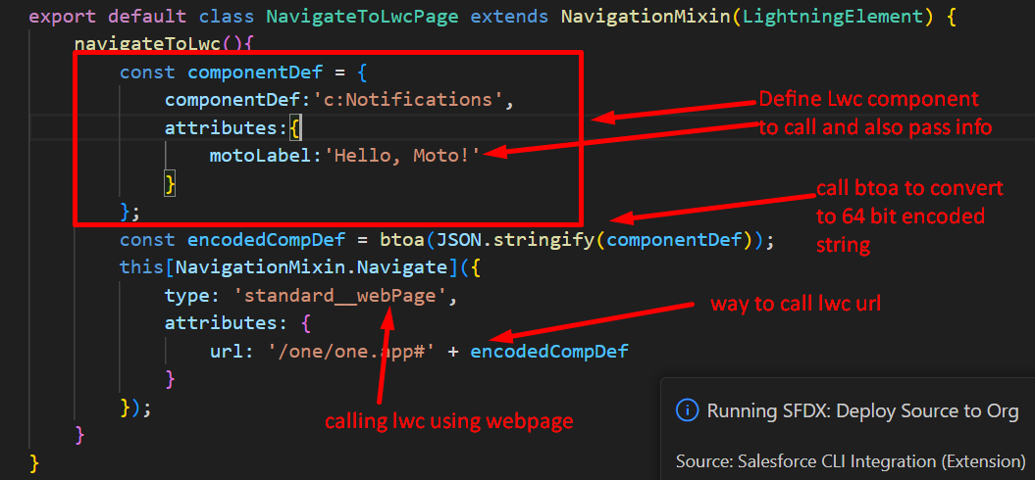

## Navigate to Aura component

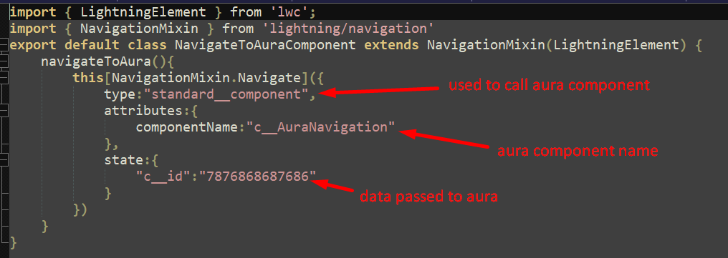

## Navigate to VF page

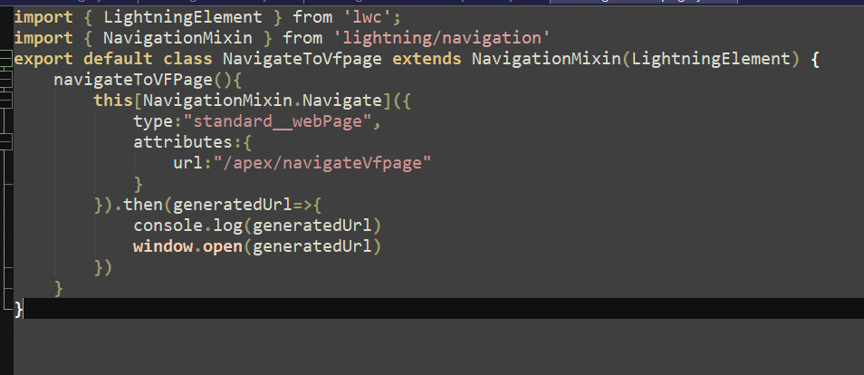

# Lightning Data Services

Centralised data caching framework built on top of UI Interface API. Saves the server again & again by caching.

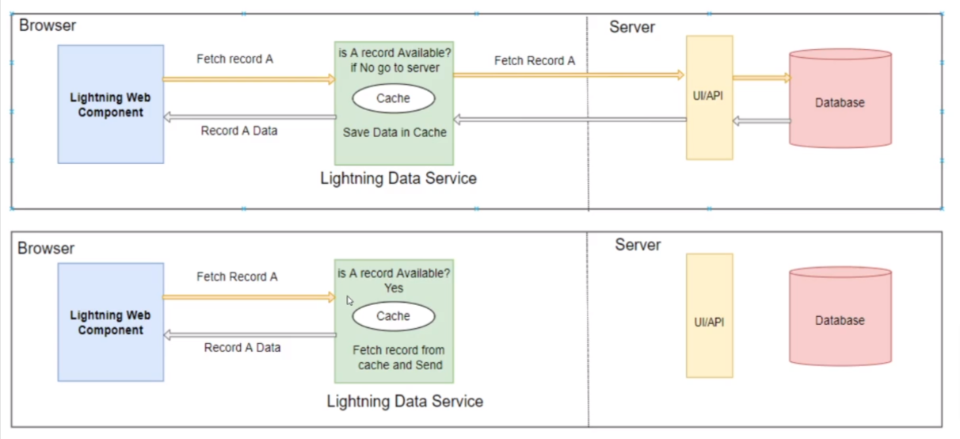

## UI API

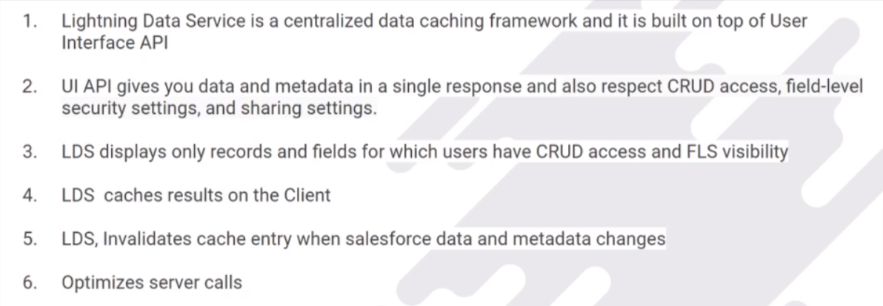

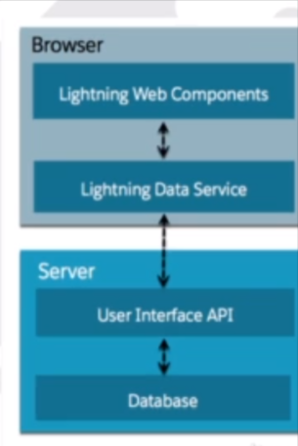

# How to fetch salesforce data?

* Through **Base Lightning Components** (built over LDS)
* Through **LDS WIRE adapter & functions –** More Flexibility
* Through **Apex** – Complete control

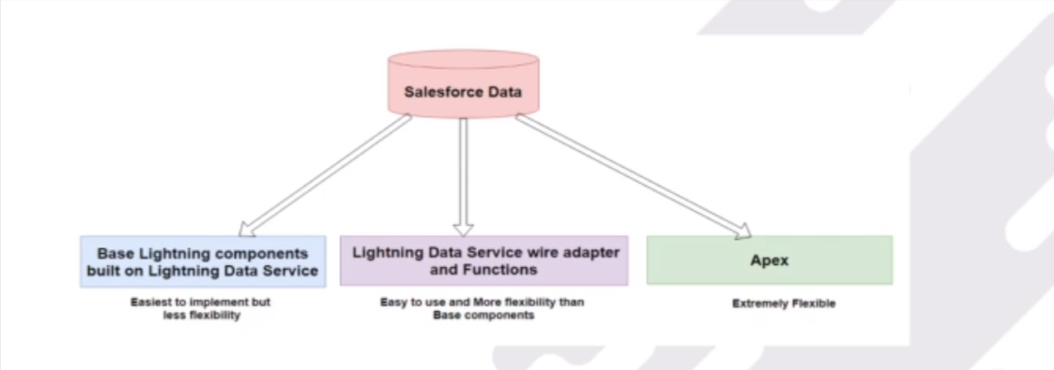

## Through Base Lightning Components

These components used LDS behind the scenes which inherits its caching & synchronisation capabilities.

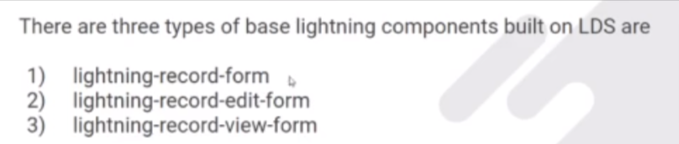

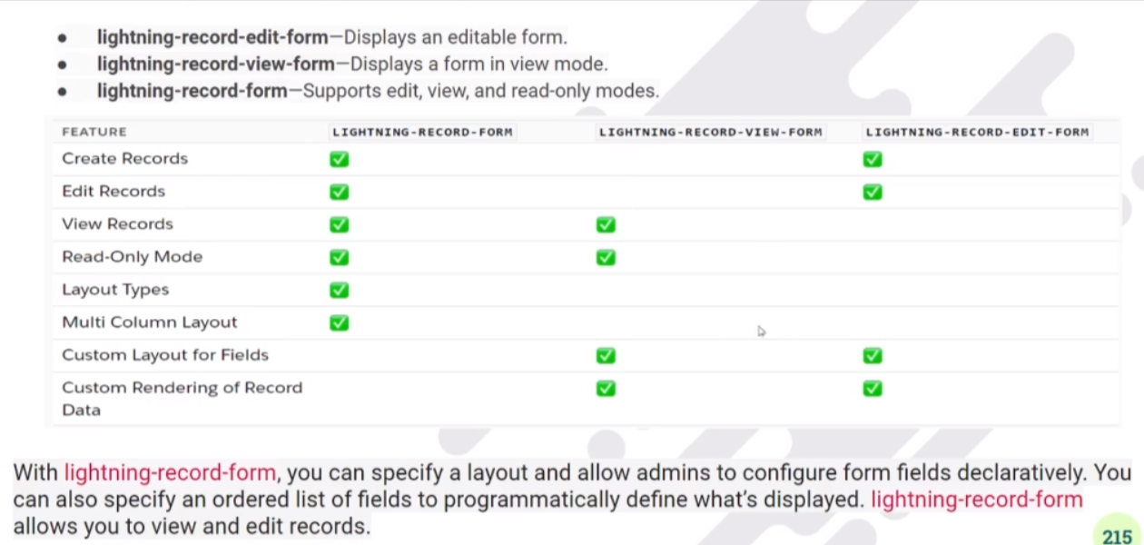

## Create a Record using Lightning-record-form

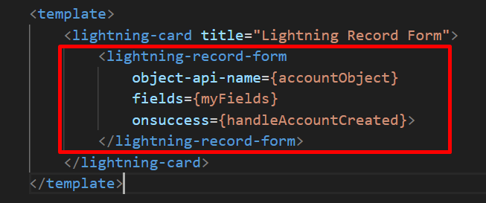

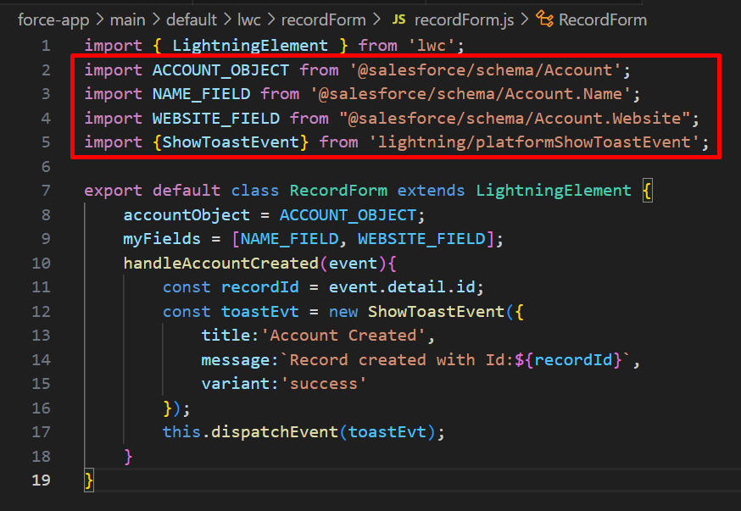

## Display using record-form

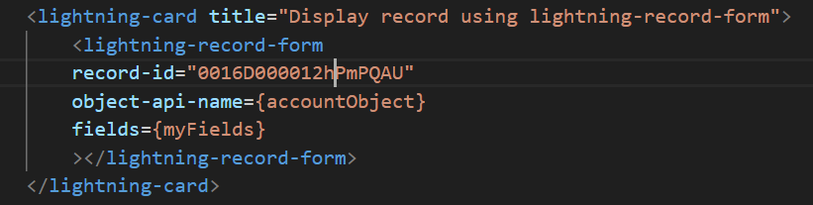

## Display record in read only mode

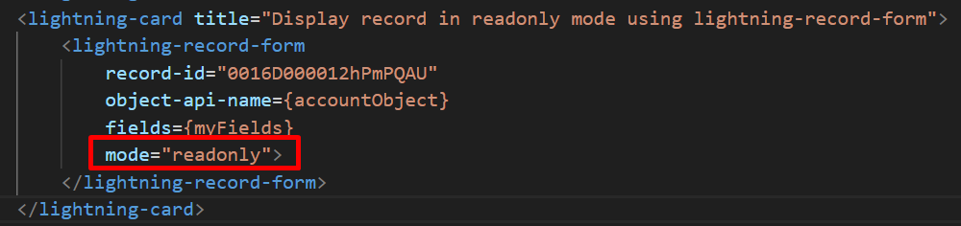

## Edit record with edit mode & with column

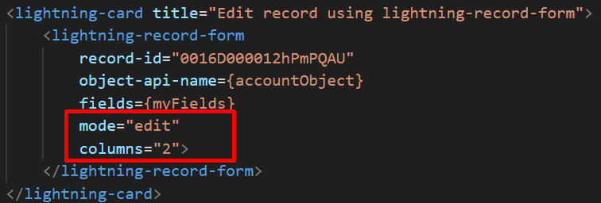

## Edit record with layout property

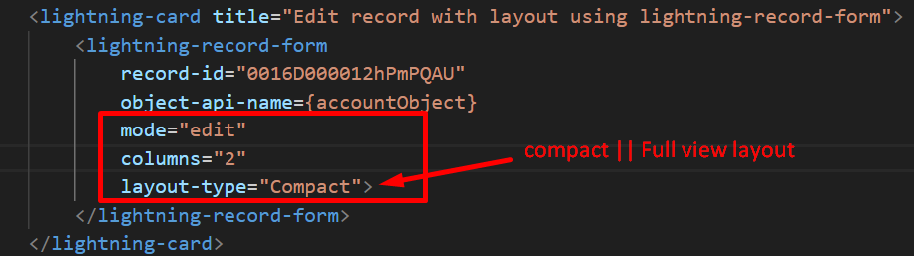

## Lightning Record View Form

Here the flexibility is to customise the layout of the fields.

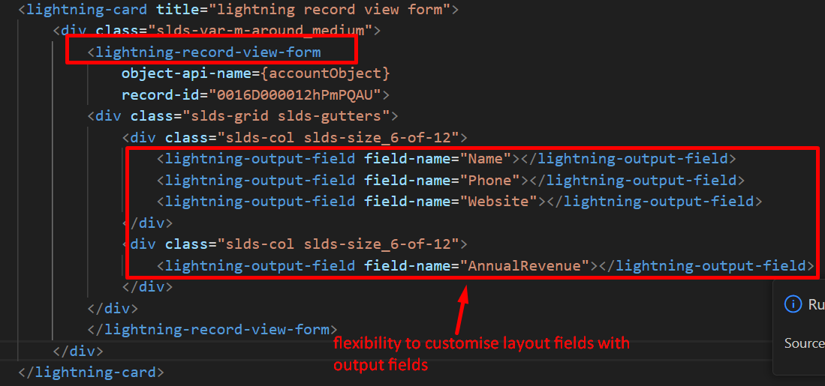

## Lightning-Edit-Form

* Provides flexibility to customise record page layout and that too in editable mode.

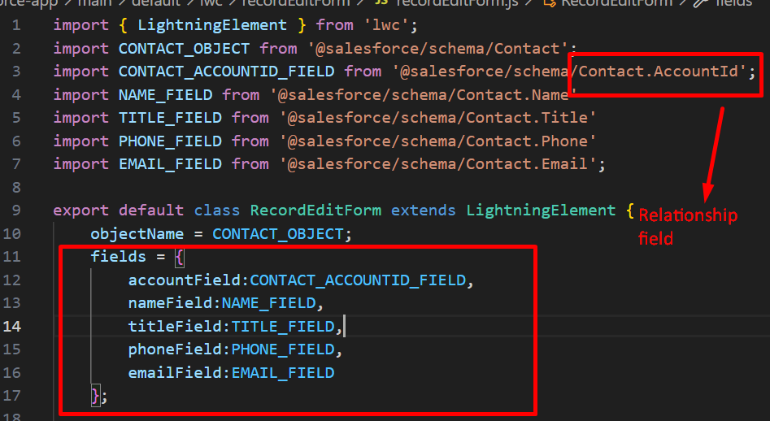

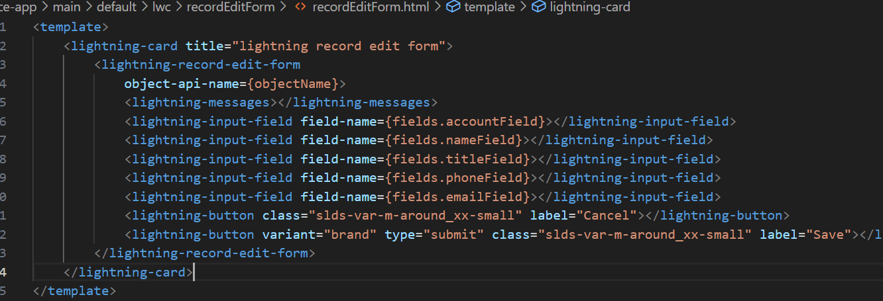

## How to reset record-edit-form ?

Add this method on cancel button.

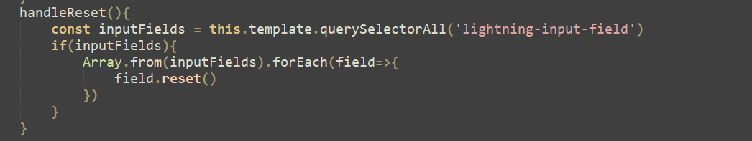

## How to show custom label on fields in record-edit-form ?

* Add attribute variant=”label-hidden” to hide the default label on lightning-input-field.
* Add label element with some styling.

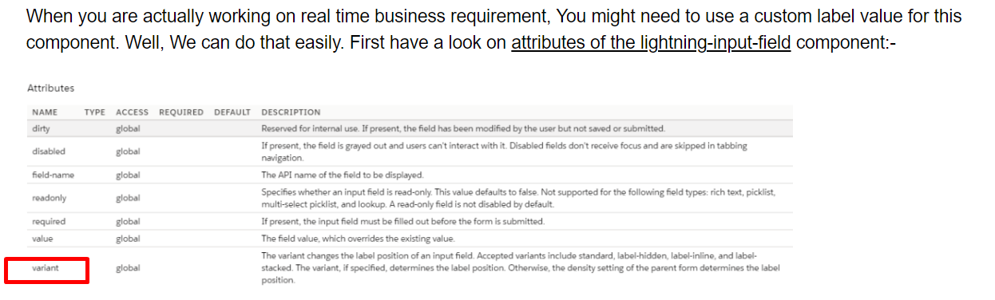

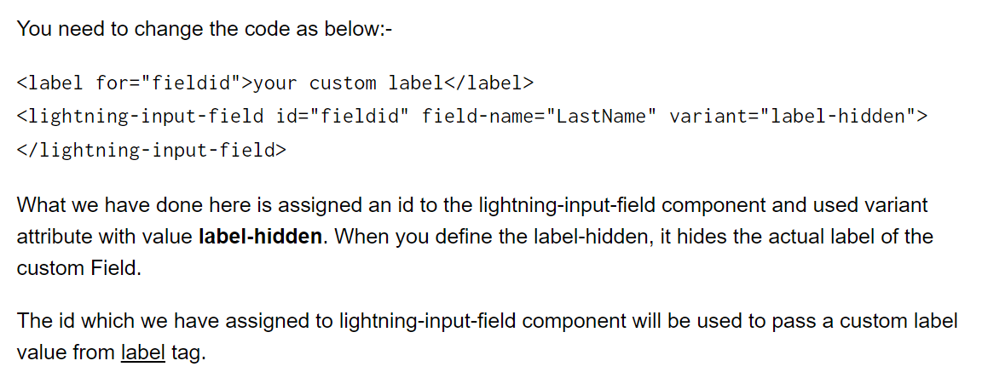

## How to create record in record-edit-form with all customised fields & validations ?

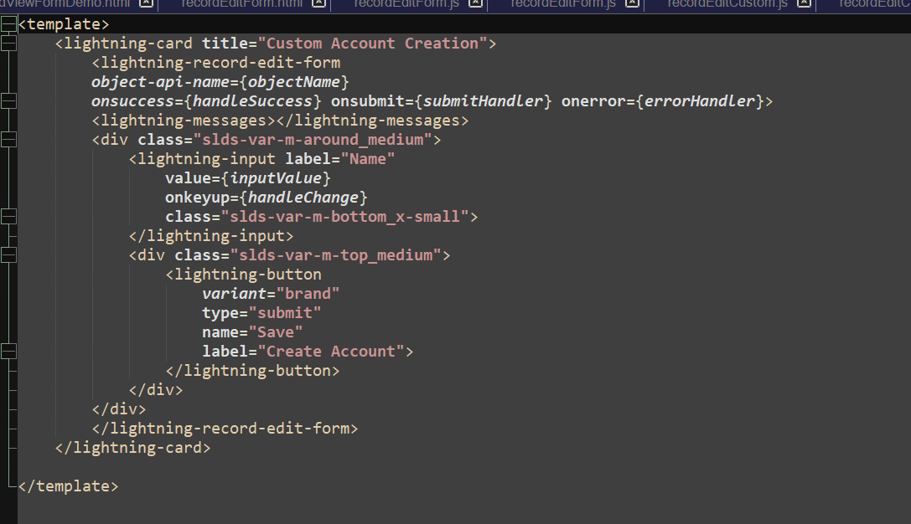

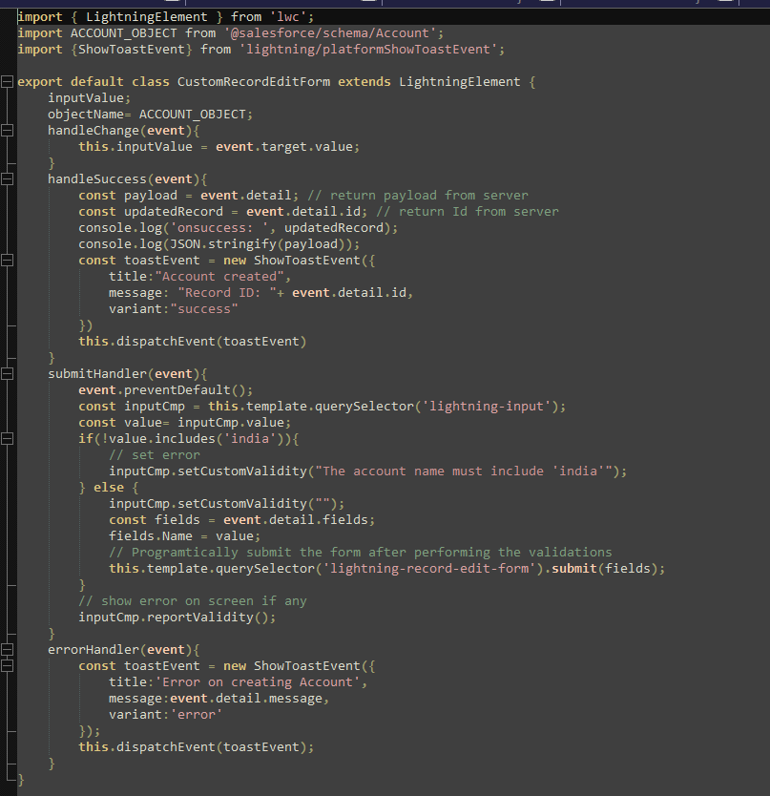

## Through Lightning Data Services Wire Adapters & Functions

* **Lightning/ui*Api** **module** provides wire adapters & functions.

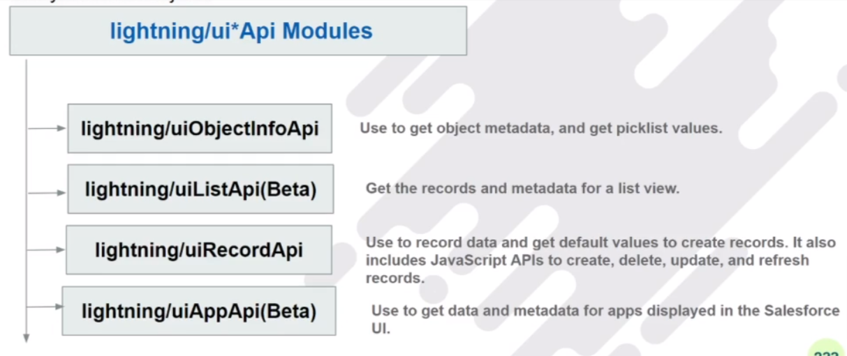

What is @WIRE service?

* Built on LDS
* Wire is reactive service.
* LWC component use @wire in their JS coding to read data from one of wire adapter available in lightning/ui*api module.

## Fetch user details using wire service?

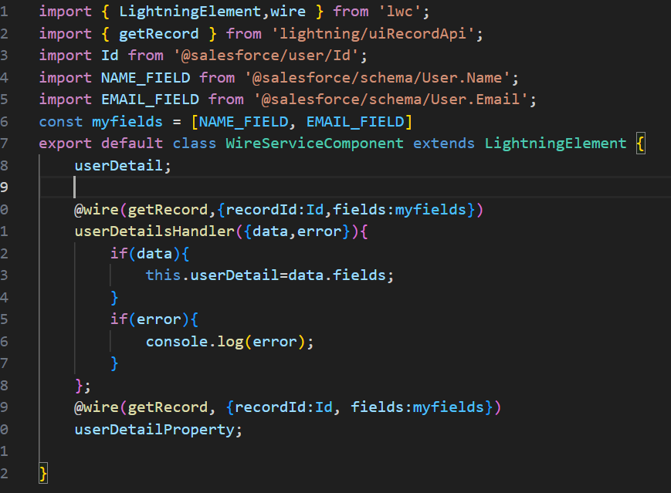

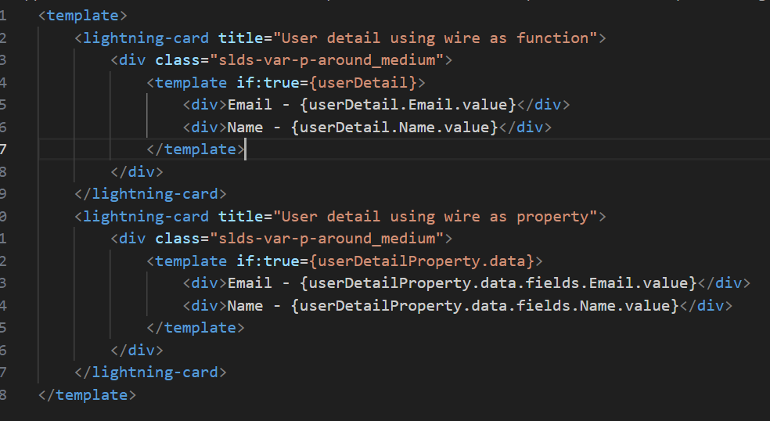

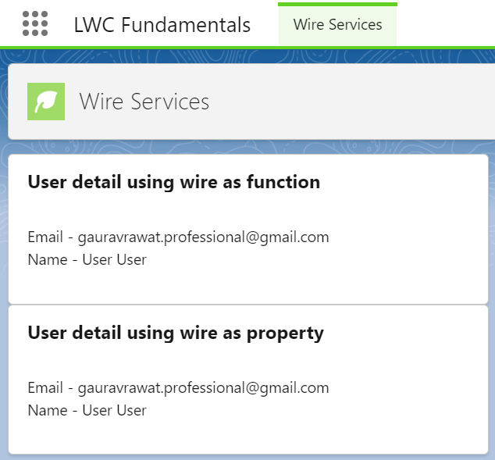

## Wire Adapter : getObjectInfo

* getObjectInfo from lightning/uiObjectInfoApi module

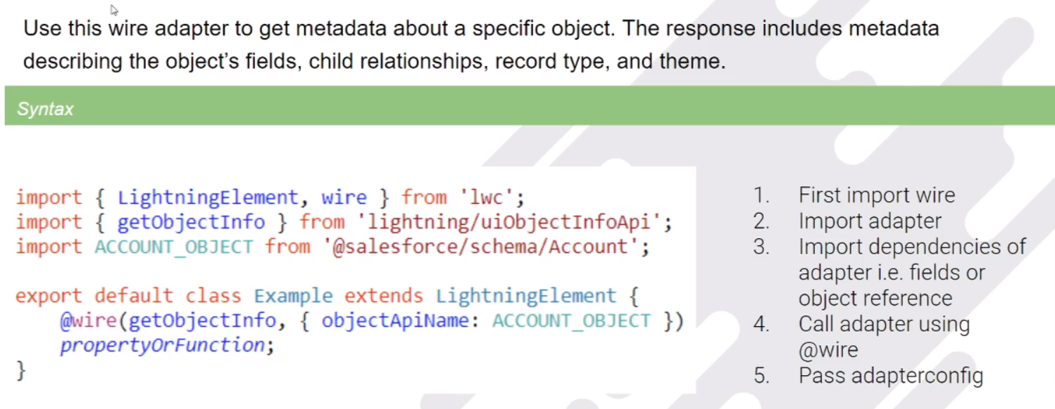

#### Using wire function

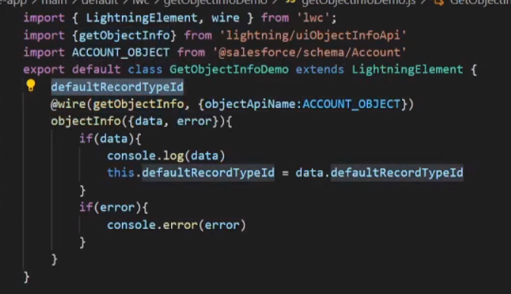

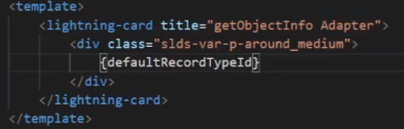

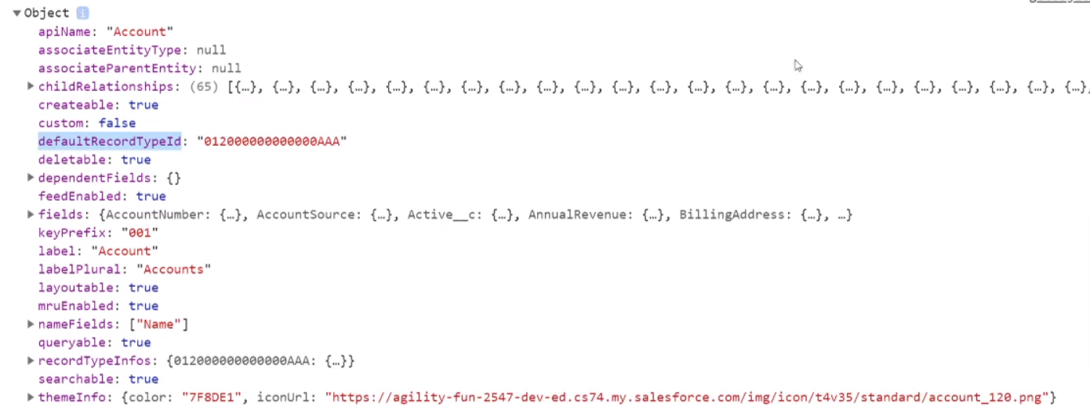

#### Using wire property

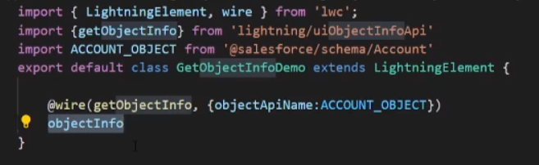

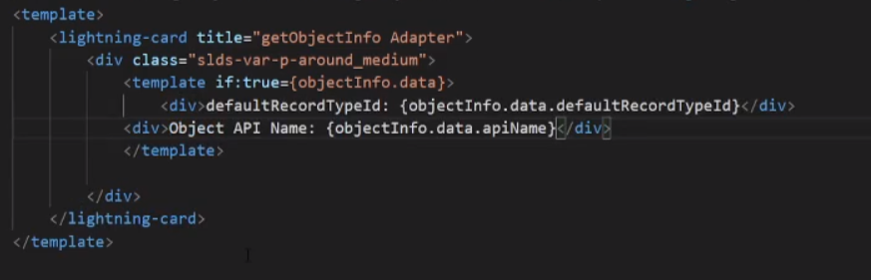

NOTE: If we don’t wrap the expression inside div within template element, if we are using wire with property, then it won’t render the values properly as wire service are asynchronous in nature.

## Wire Adaptor: getObjectInfos

* get multiple object metadata in single call

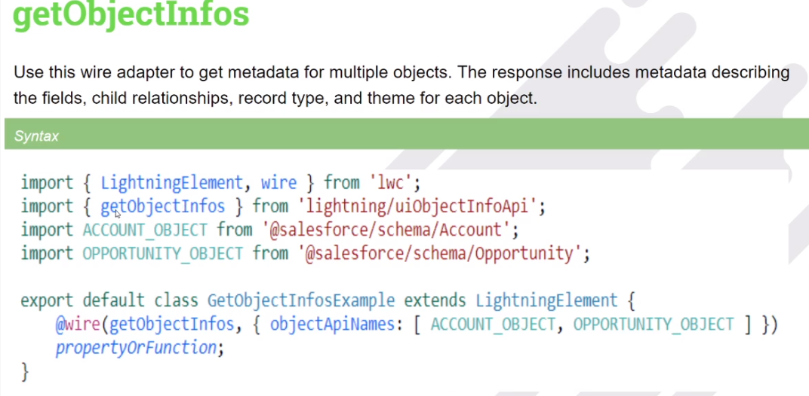

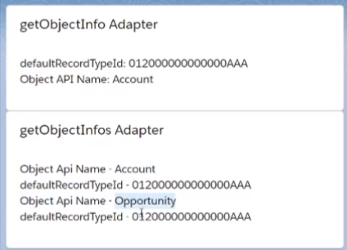

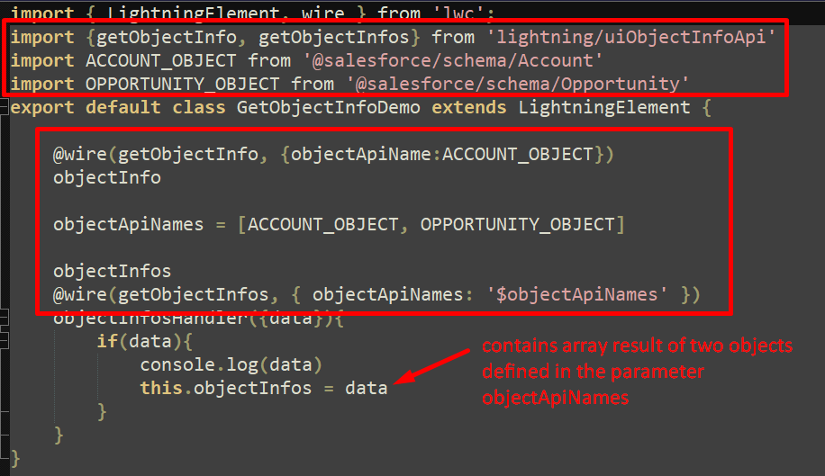

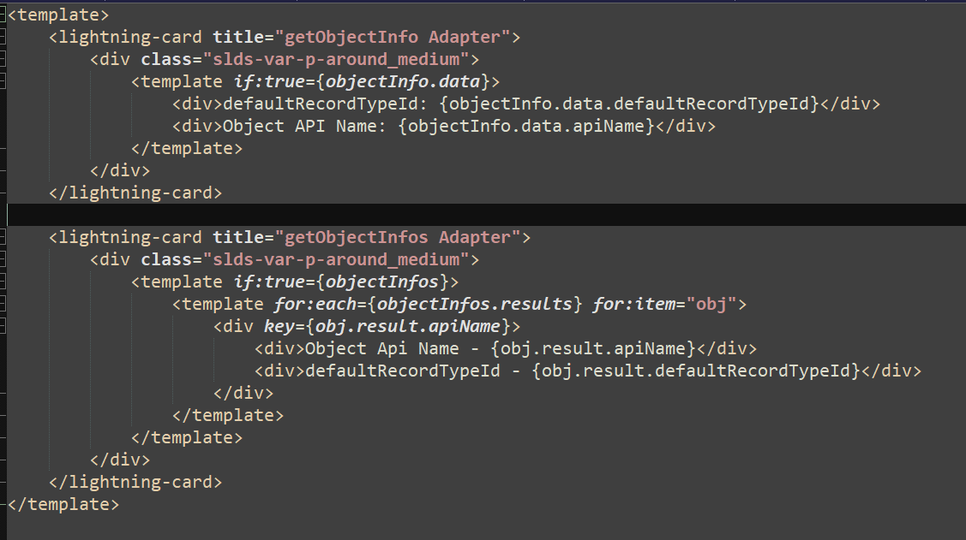

## Wire adapter: getPicklistValues

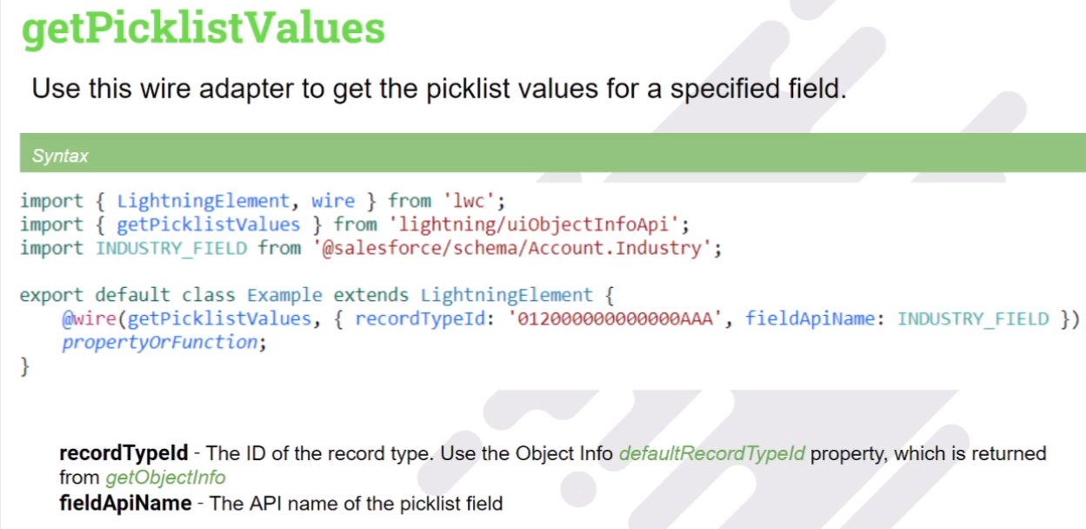

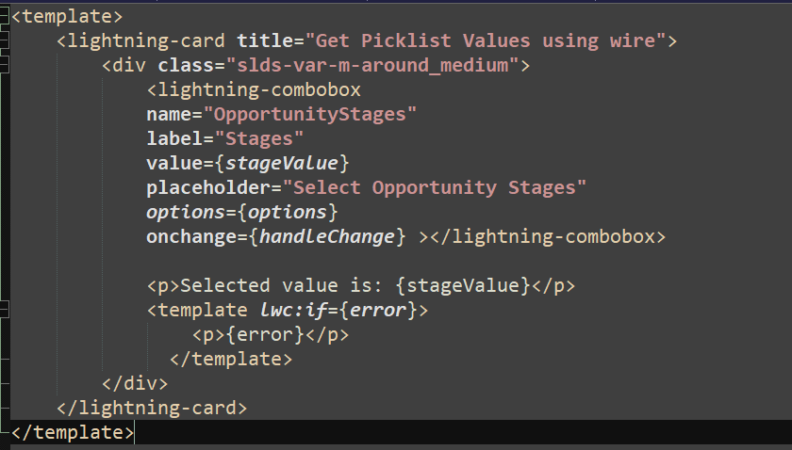

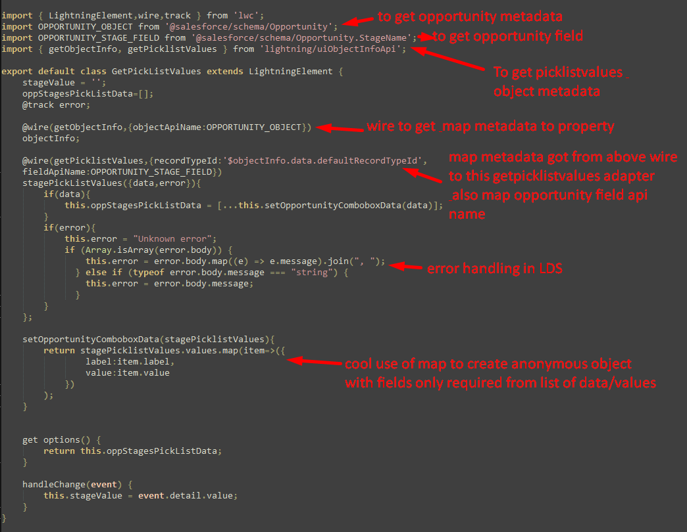

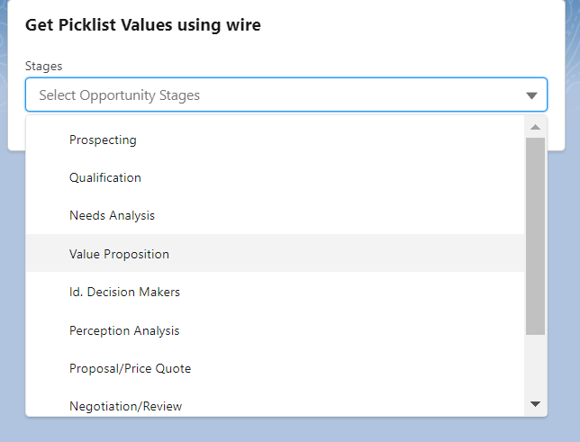

## Wire Adapter: getPickListValuesByRecordType

* It overrides the drawback of getpickvalues adapter wherein we have to add adapters for multiple picklist values.

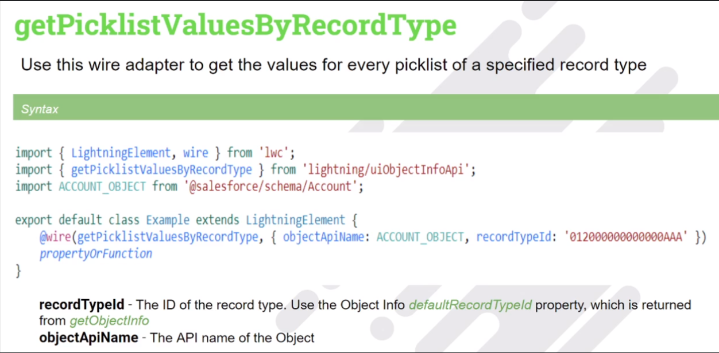

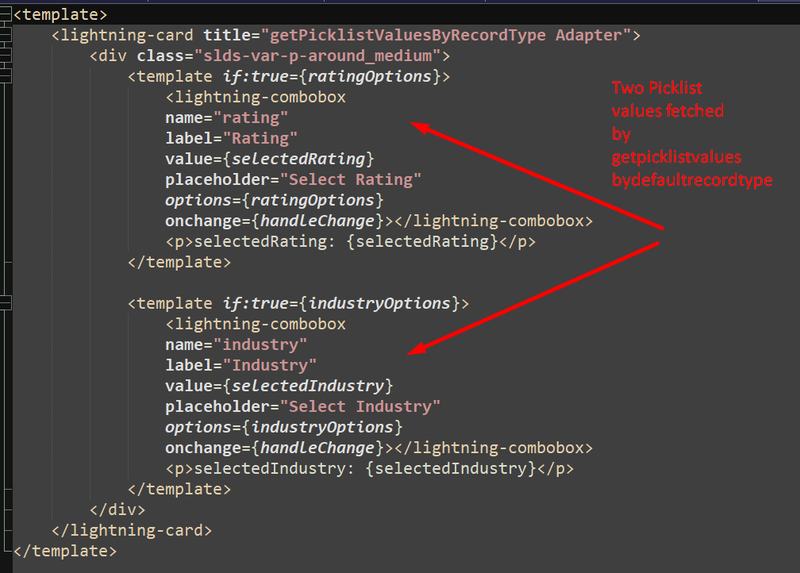

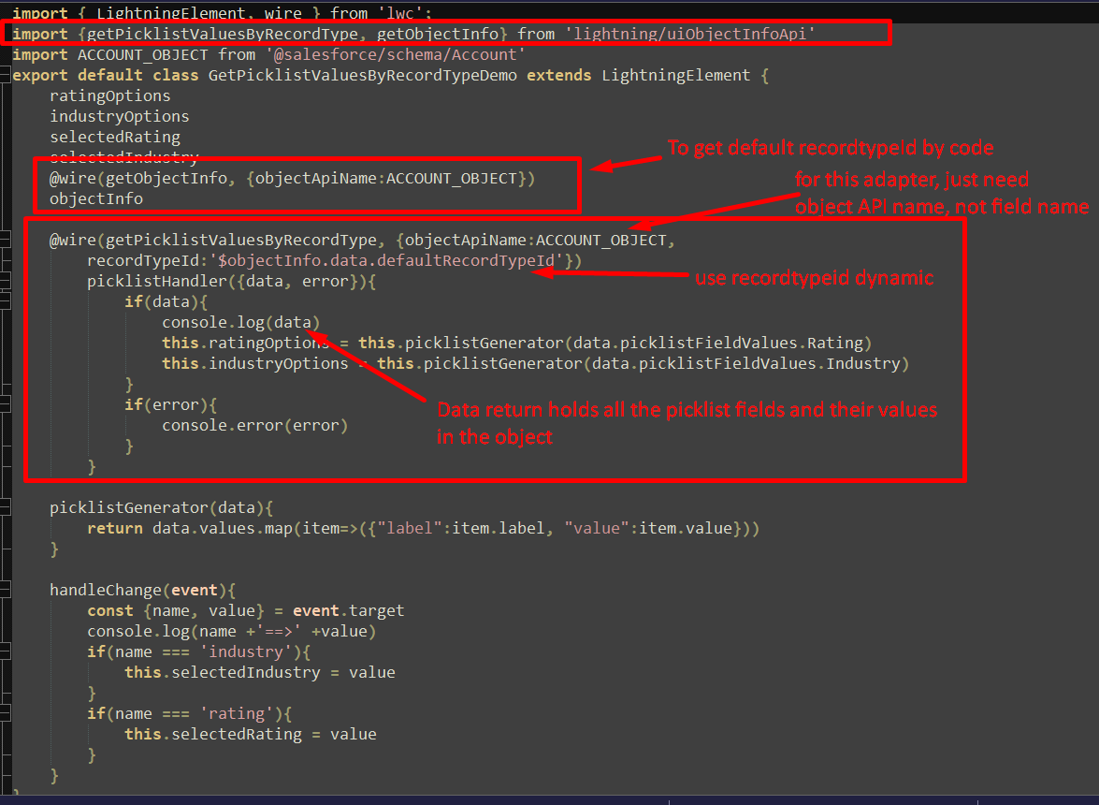

## Wire Adapter : getRecord

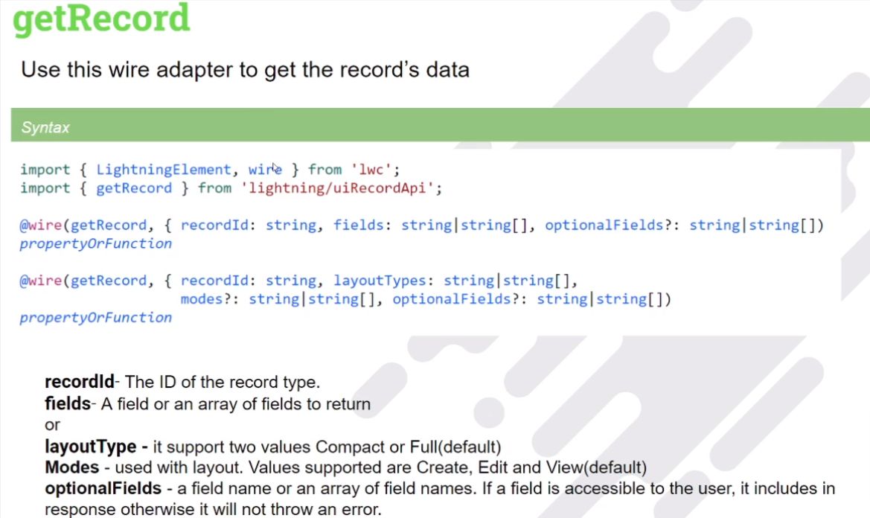

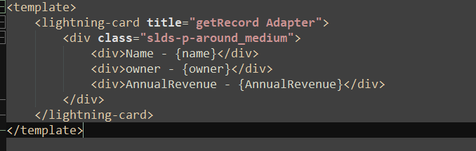

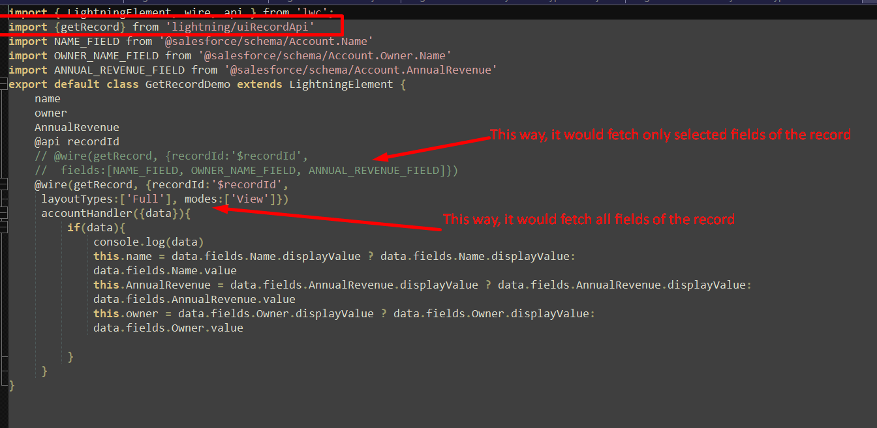

## Wire Adapter Function: getFieldValue & getFieldDisplayValue

What if we want to get only field value from the record, not all the fields?

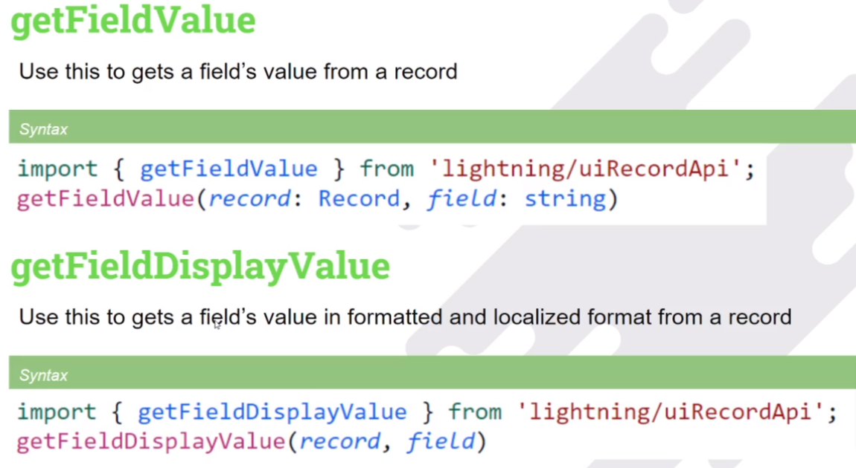

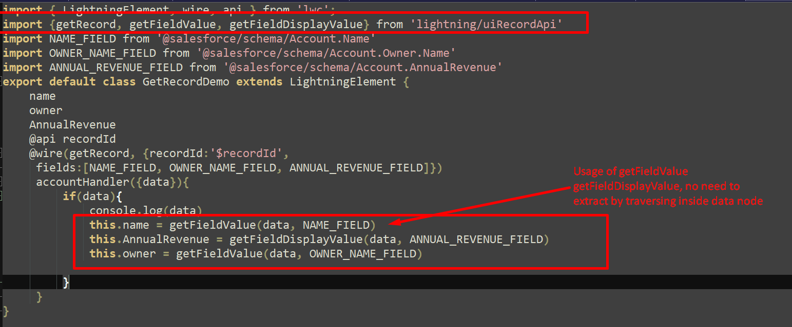

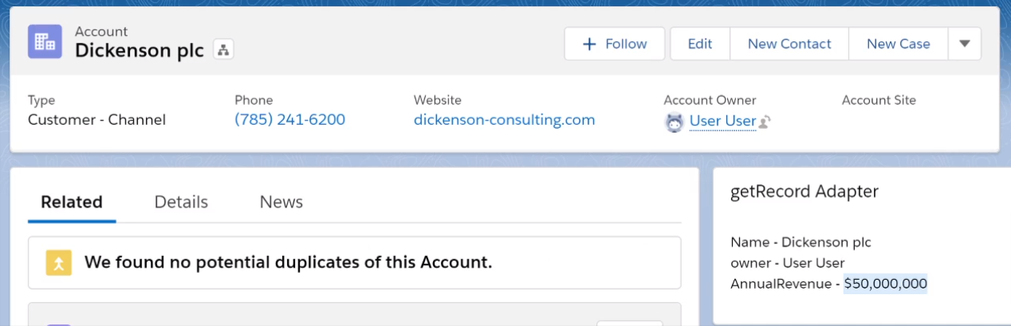

## Wire Adapter: getListUi

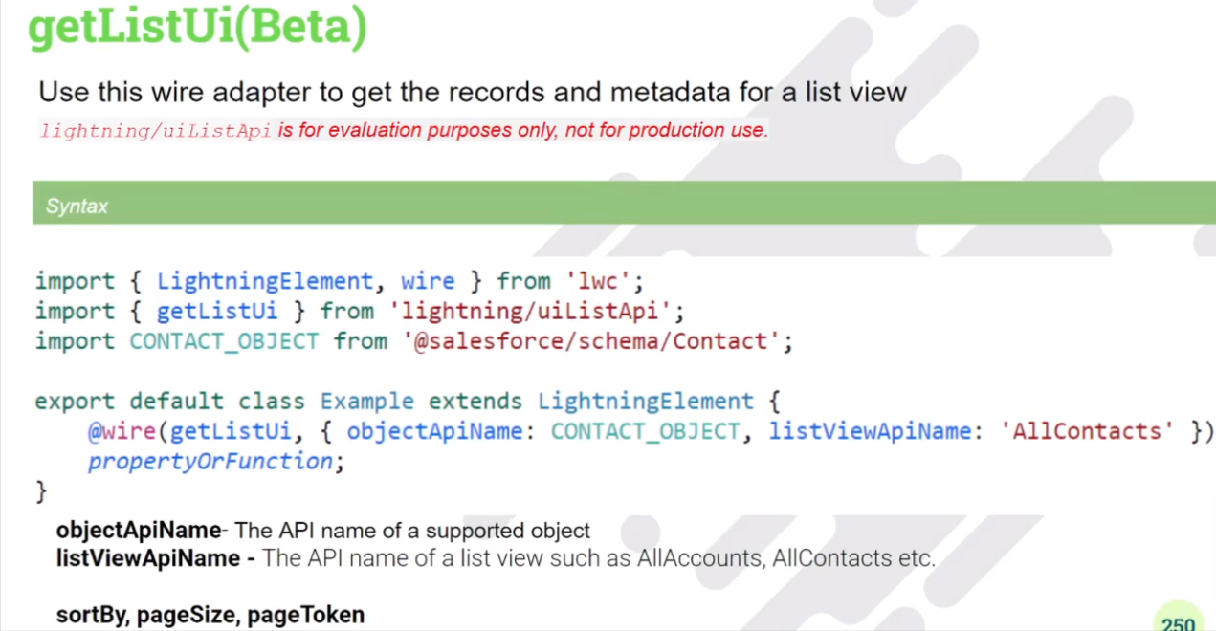

## How to do pagination using Wire Adapter : getListUI (Deprecated)

* To get specific list view records and metadata.
* To achieve pagination using this single adapter

